Charity Registration Number Sco48512
Welcome to Perth Road Runners
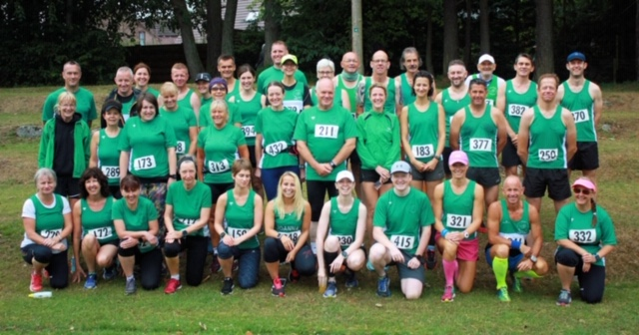

We have put together this welcome pack as an induction to Perth Road Runners. Here you will find some of the information we feel is the most important and links on how to find out more.
The first and most important part of Perth Road Runners is that it is open to anyone who enjoys running. You might want to improve your pace, get advice on training for an event or simply want to meet other runners. We are also open to all abilities from seasoned ultra-marathon runners to individuals who are new to running. We just ask that you have a pair of trainers and a positive attitude.
We meet every Tuesday Night at 6.30pm at Bells Sports Centre and go out in various groups depending on pace and distance. When you first join we will help you find the group that best suits your running style and goals.
We also run on Thursday nights, with sessions alternating between the George Duncan Athletics Arena at Perth Grammar School and either Kinnoull Hill or Taymount Terrace, depending on the time of year. These sessions are also at 6:30pm and you can find details on where each week’s session is taking place on the Calendar section of our website.
Perth Road Runners is a registered charity and we pride ourselves on being a friendly club.
We follow a set of simple rules which keeps everyone happy and allows the club (and its members) to keep running
1) Come along and have fun. As a new member of a club that is increasing in numbers, we understand it can be daunting when you first join. We want you to feel part of the club and to feel comfortable running with us. If you have any questions or need some extra support to feel included, let us know.
2) When you go out and do a race let the media volunteer know about it. You can find out more information about this on the committee page.
3) You can purchase club clothing on the first Tuesday of every month. If you are planning to compete in the championship or any other of the club series, you will be required to wear a PRRs top. If you do not wear club clothes you will not earn points for the race. See the information on the Club Series for more information.
4) Once you have joined Perth Road Runners and have settled in, please volunteer for some of the roles required to keep the club running. This could be meeting and greeting new members on a Tuesday night, or helping to organise one of the club runs. You will be fully supported by other members for this.
5) If you have any concerns or issues relating to the club please contact the Welfare Officer in the first instance. Their role is to help anyone in this position and more information can be found on the committee page.
The majority of this information and more detailed accounts of each section can be found on our website www.perthroadrunners.co.uk. If you use Facebook our club members’ only page can be found at https://www.facebook.com/groups/599915970056151/ You can also follow us on Twitter @PerthRdRunners

Welcome to Perth Road Runner’s Committee members
Perth Road Runner’s is trustee led, which means it is run by a group of volunteers. These are the following positions members take a lead on in the committee and contact details if you have any questions.
Chairperson – Basically the boss (or the president as they seems to think they should called). The Chairperson takes the lead on the committee meetings and the direction the club is moving towards. We look for feedback on how we can improve the club and these can be directed to the Chairperson at chair@perthroadrunners.co.uk
Vice chairperson – 2nd in charge and therefore I guess could make a claim to be known as vice president. Supports the chairperson and can be contacted in the event the chairperson is unavailable on vice@perthroadrunners.co.uk
Secretary – Like every secretary up and down the country, Perth Road Runners Secretary is responsible for the everyday running of the club and should be the first point of contact for general enquires (secretary@perthroadrunners.co.uk)
Press – Completes the press reports for the local newspaper every week and is very passionate about club members emailing in their results. If you complete a race, let us know about it and enjoy having you name and time printed in the Perthshire Advertiser (PA). If it’s not in the PA did it even happen? Learn this email address off by heart – press@perthroadrunners.co.uk
Treasurer – Sometimes also referred to as the debt collector, the Treasurer is responsible for keeping our accounts up to date and ensuring we don’t over spend (not an easy task). If you have any money questions these can be directed to treasurer@perthroadrunners.co.uk. It would be helpful if you kept these related to the club accounts.
Membership Coordinator – Sometimes also referred to as the debt collectors side kick, the membership trustee is involved in setting up Entry Central each year and keeping a log of all members. Any questions regarding your membership with the club can be emailed to membership@perthroadrunners.co.uk
Club Clothing – This role involves keeping all members kitted out in the best running gear possible. Going to a race in Perth Road Runner tops is like a fashion statement. We are planning to make clothing available on-line in the future and will keep you up to date about this. Any quires contact clothing@perthroadrunners.co.uk
Welfare Officer – Like having our own club social worker. The Welfare Officer should be the first point of contact if you have any disagreements or complaints about Perth Road Runners – welfare@perthroadrunners.co.uk
Web organiser – the trustee who moonlights as our IT guru (and is also the reason you are currently reading this on the website, thanks Alan). Any missing information let this trustee know at info@perthroadrunners.co.uk
And finally, the one and only Championship Organiser. As a club we have three race series that happen over the year. Firstly the Championship (which also lends its name to this trustee position) is a series of ten races. Club members compete against each other and to earn a Championship medal you must complete 7 out of the 10 races or 6 out of 10 races plus a marathon. If you plan on trying to get placed (1st, 2nd or 3rd) you must complete 7 out of 10 races and a marathon. The summer series and the hills series are smaller events and members compete against each other over roughly 5 races. The races for each event change on an annual basis and if you want to see a particular race in any of the series the advice would be make friends with this trustee championship@perthroadrunner.co.uk
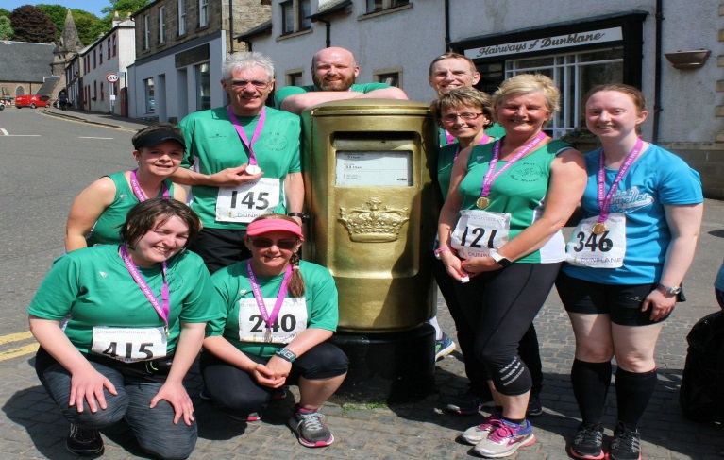
Some club members at the famous letter box after a championship race at Dunblane.
Please remember that all positions are run by volunteers. We always love hearing from club members (or potential members) but we can’t always reply straight away.
These positions are open to any club member and if you don’t really enjoy having spare time, you can put themselves forward for any of the trustee roles. The roles are decided for the year at the annual AGM, which is normally held in November.

Club races and events
We are currently working very hard (ok working hard-ish) on putting together a diary of events so members have a yearly calendar with set dates for all of the below. We will email the diary to all members when it is done. Here is a short overview of all the exciting races and social occasions we put on throughout the year.
Perth Road Runner Duathlon
We do not always run, sometimes we do a duathlon. This event is normally held in September in Pitcairngreen. It involves a 4.2 mile run followed by a cycle of 12.2 miles and participants can do both events or join up in a relay team.
Target Zero
Want a race that is open for anyone to win? Come along to Target Zero which is about predicting your time over a distance of approximately 5 miles. The course is kept a secret until the day of the run and the person with the most accurate time (ie their actual time is closest to their predicted time) wins. The winner gets a trophy so there is not much to dislike about this event.
Yahoo
This is a handicapped race over 9 ½ miles and is a staggered start time. First runner back to Bells wins. This race is normally held in December and is open all club members. To make it extra challenging this event is normally held in December and therefore being good at ice skating is an advantage.
North Inch Relay
Join up in teams of 3 for a relay race around the Inch. Each participant runs approximately 800m meters and you are going to have to be pretty speedy to beat the current record.
Wee Winter Run
If you want a hill race in mid-February, and normally being held after a night out this is a great choice. Also the club have sit down for lunch at the Cherrybank Inn afterwards. No better way to spend a Sunday.
Tay Ten (10 miles) and Brig Bash (5 miles)
These two are both popular races which are organised by the Race Sub-Committee, and are entered through Entry Central. We encourage club members to volunteer or enter these races. They really are great events. If you need more information or would like to join the race sub-committee you can email the team on racecommitee@perthroadrunners.co.uk
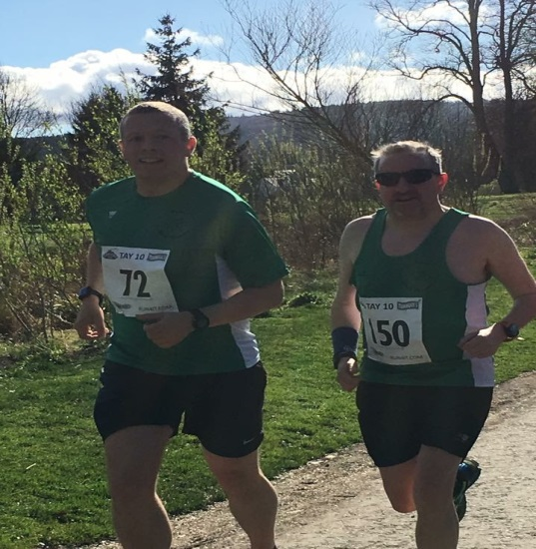

Perth Parkrun Take over
Every year the club take on all the volunteer positions at Perth parkrun. This helps us promote the club as well as supporting the local parkrun.
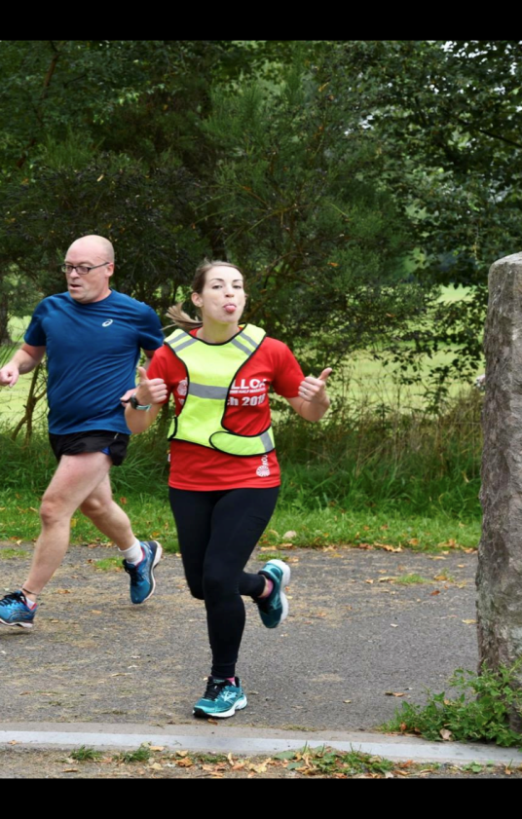
Look how happy volunteering makes you
Club standards
If you fancy a challenge based on improving your running times over various distances why not look into the club standards.
http://www.perthroadrunners.co.uk/membership/club-standards/
Car sharing
We encourage car sharing to all races. The meeting point for car sharing is Broxden park and ride. This is a great way to cut the costs of travelling to races and all to meet other members.
Christmas night out
It does not take a rocket scientist to work out our annual Christmas night out happens in December. Tickets are be purchased by bank transfer to the club account – sort code 80-22-60, Account number 18224160.
Presentation Night
The night when your hard work is rewarded (or just a reason for a social night out depending on your viewpoint). Again tickets for this are purchased by bank transfer and medals are presented to club members for various running achievements through the year.
Annual General Meeting
Our AGM is held in November. Come along and have a say in how your club is run. If that does not entice you, then it is also when you find out who got into London Marathon through the club ballot and discover who is the club personality of the year.

Happy running road runners

