PA 21 February 2014
Perthshire’s Brand New 10 Mile Road Race Launch
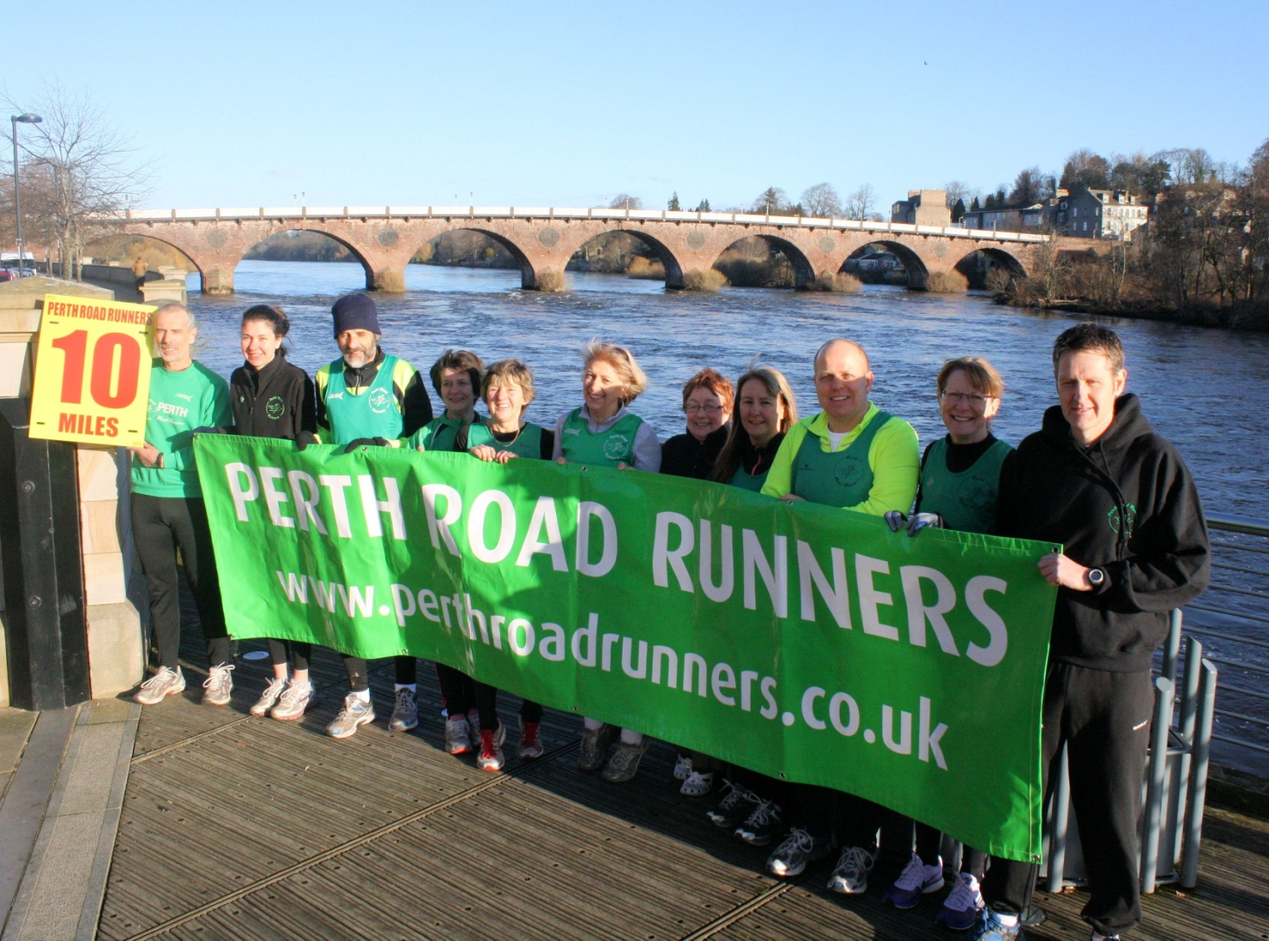
Perth Road Runners recently launched an exciting new Perthshire 10 mile road race – The Tay Ten. The race is a flat, fast course on riverside paths and ‘B’ roads, with great potential for PBs. The Tay Ten has a stadium start/finish at the George Duncan Athletics Track in Perth. The inaugural race will take place on 6 April 2014 with an 11am start. Registration and changing is at the North Inch Community Campus and runners will then have a very short walk to the start/finish at the George Duncan Track. Prizes, refreshments, showers, and post race massage (courtesy of Caledonian Physiotherapy Services) will be available. Entries from Entry Central online only – sorry no entries can be accepted on the day. Further information on The Tay Ten is available on PRRs website www.perthroadrunners.co.uk. PRRs thanks to Sweatshop, Highland Spring and Tunnocks for supporting The Tay Ten.

At the recent Annual Presentation Dinner, Club Standards awards were presented to club members who have achieved challenging performance standards for their age and gender. Club Standards are goal times for six race disciplines ranging from 5k to Marathon. PRRs Club Standards Award winners were Bronze – Linda O’ Neill and Simon Grieshaber; Silver - Nicola Crowe; Gold – Fiona Angus. A rare Diamond Award was picked up by a delighted Fiona Hair.

Club members are reminded that the next Club Championship race is the Cupar 5 on 1 March.
233 words
Neil Muir, Nicola Crowe, Kenneth Stewart, Susan Smith, Fiona Hair, Karen Walters, Veronica Muir, Fiona Morrison, Alan Paterson, Sally Newton, Derek McIntosh

