The courier

Club Celebrates 2013 Prize Winners or
Bob joins the ‘100 Marathon Club’
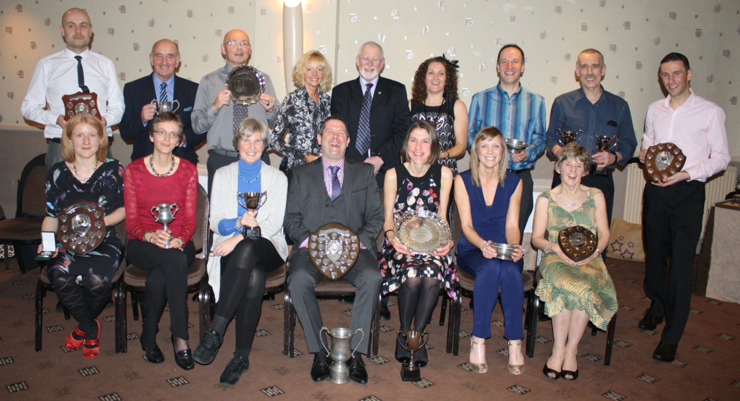

Nearly sixty of Perthshire’s finest runners gathered at the Lovat Hotel, Perth on Saturday 8 February for Perth Road Runners annual presentation dinner. The runners were pleased to welcome Councillor Bob Ellis as guest speaker to present the prizes to club members. Bob gave a very entertaining talk including the origins of Perth Road Runners, their links to Blairgowrie and tales of the exploits of the various club characters, some of whom are today’s PRRs Super Vets! Coming right up to date Bob appreciated the participation of 35 PRRs in the 30th anniversary of the Ne’er Day Race at Blairgowrie, which was this year’s first Club Championship race of the season.

In all 15 ladies and 13 men collected prizes covering all race disciplines from 10k to marathon. The winners of the Club Championship were Nicola Crowe and Stuart Robertson, the runners up were Sue Jones and Jimmy Fotheringham with 3rd place honours going to Beth Gripton and Barry Campbell. The Super Vets Club Champions were Fiona Hair and Bob Brown. The winners of the Club’s Summer Series races were Julie Ramsay and Simon Grieshaber. Pete Ritchie scooped numerous honours including Club Personality of the Year and the Jean Wainright Most Adventurous award for his overseas running adventures. Bob Brown, celebrating his 70th birthday this month, proudly picked up a trophy in recognition of his joining the coveted 100 Marathon Club. Kenneth Stewart is hot on Bob’s heels for joining the eponymous 100 Marathon Club this year!

Club members are reminded there is a photocall next Sunday 16 February at 9.30 on Tay Street, at bottom of High Street, before the Wee Winter Run. The next Club Championship race is the Cupar 5 on 1 March.

286 words

Back Row
Mark Leach, Bob Brown, Pete Ritchie, Fiona Angus, Councillor Bob Ellis, Allison Brown, Simon Grieshaber, Neil Muir, Tony Jackson
Seated: Melanie MacRae, Sue Jones, Anne Wombill, Stuart Robertson, Nicola Crowe, Julie Ramsay, Fiona Hair

