First run in 2007, and annually ever since, Perth Road Runner’s Wee Winter Run recently took place. It’s a free, local, off-road run available for all club members to enter. The entrants range from cross country aficionados to members trying out the dirty stuff for the first time. The weather was perfect on the day, winter snow having melted, with just a couple of icy patches and plenty of mud in the woods to keep everybody focused. This year 19 club members took advantage of the run to pit themselves against the Buckie Braes, St Magdalene’s Hill and Hilton Hill route, with its far reaching and spectacular views over the Fair City and the surrounding countryside.

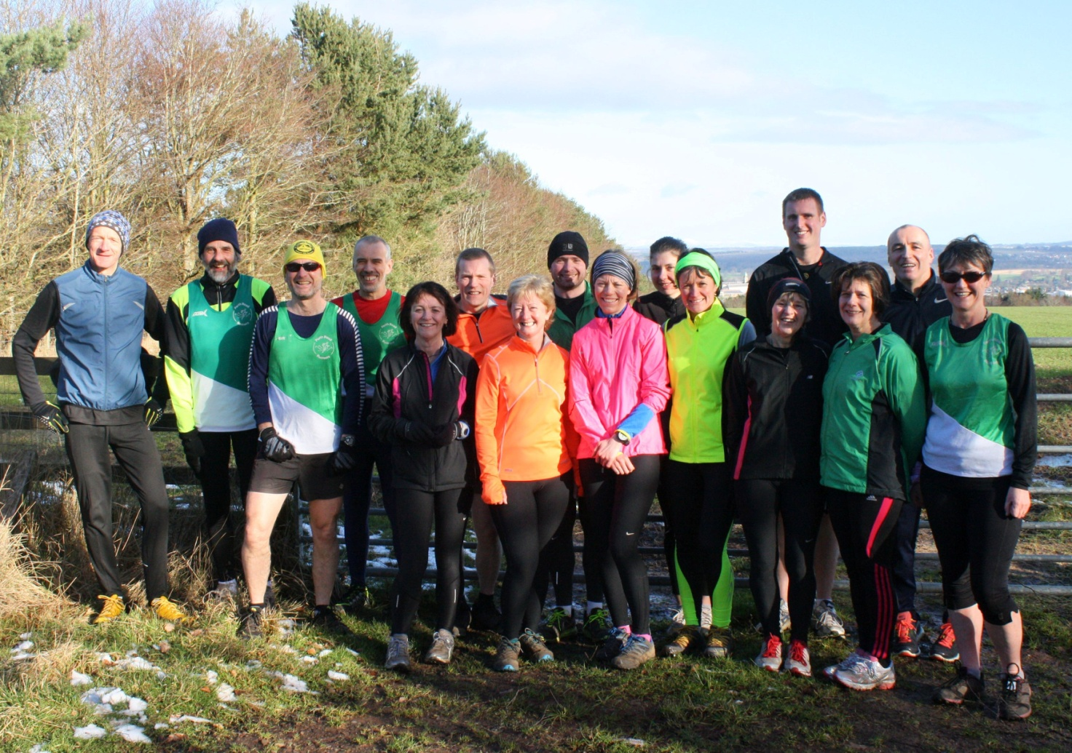
At the sharp end, battles between Neil Muir and Derek McIntosh saw Derek coming in 10 seconds ahead of Neil for the men and Denise Burns, 12 seconds ahead of Joan Wilson, for the ladies. Several members ran the event for the first time whilst others, well into their training for marathons and other long distance events, added the run to the end of their Sunday morning long runs. As always post race many of the runners retired to the comfort of the Cherrybank Inn to the excellent hospitality supplied by Jack and his team.

Finally, thanks must go the members who didn’t run on the day but marshalled to ensure the event ran safely and smoothly, they turn out every year in all weathers and without them there’d be no event.

The next PRRs Club Championship race is the Cupar 5 on 1 March.

263 words

